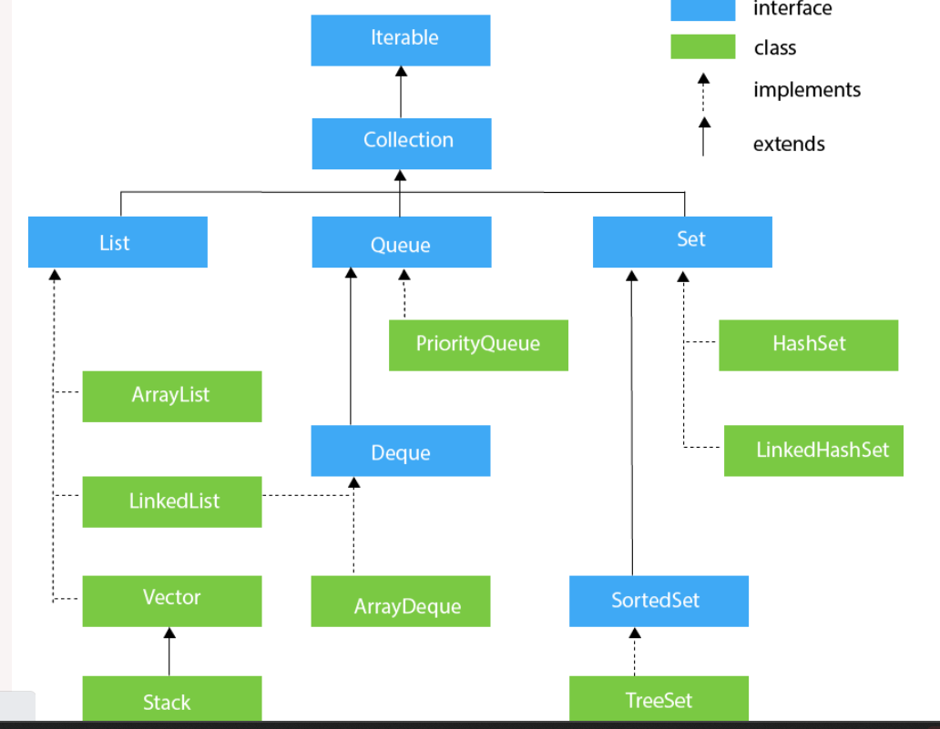

1️⃣ Java Collections Framework (JCF)
📌 Definition
The Java Collections Framework is a set of interfaces and classes used to store, manipulate, and process groups of objects efficiently.
📌 Components
- Interfaces – Define behavior (List, Set, Queue, Map)
- Classes – Concrete implementations (ArrayList, HashSet, HashMap)
- Algorithms – Sorting, searching, shuffling (Collections class)
📌 Advantages
- Ready-made data structures
- Improves performance
- Reduces coding effort
- Type-safe using Generics
- Supports concurrent programming

2️⃣ Collection Interface
📌 Overview
- Root interface of the collection hierarchy
- Present in java.util
- Parent of List, Set, and Queue
📌 Important Methods
Method | Description
add() | Add element
remove() | Remove element
size() | Total elements
isEmpty() | Check empty
contains() | Search element
clear() | Remove all
iterator() | Traverse

3️⃣ List Interface
📌 Characteristics
- Maintains insertion order
- Allows duplicate elements
- Index-based access
📌 Common Implementations
Class | Description
ArrayList | Dynamic array
LinkedList | Doubly linked list
Vector | Synchronized
Stack | LIFO structure

🔹 3.1 ArrayList
📌 Features
- Resizable array
- Fast access (O(1))
- Slower insertion/deletion in middle
- Not thread-safe
📌 Use Case
- Searching, reading data frequently
ArrayList<String> list = new ArrayList<>();
list.add("Java");
list.add("Selenium");

🔹 3.2 LinkedList
📌 Features
- Doubly linked list
- Slower access
- Faster insertion/deletion
- Implements List & Deque
📌 Use Case
- Frequent insert/delete operations

🔹 3.3 Vector
📌 Features
- Thread-safe (synchronized)
- Slower performance
- Legacy class

🔹 3.4 Stack
📌 Features
- LIFO (Last In First Out)
- Methods: push(), pop(), peek()

4️⃣ Set Interface
📌 Characteristics
- No duplicates
- No index
- Used when uniqueness matters
📌 Implementations
Class | 특징
HashSet | Fast, unordered
LinkedHashSet | Maintains insertion order
TreeSet | Sorted order

🔹 4.1 HashSet
📌 Features
- Uses Hashing
- No order guarantee
- Allows one null
📌 Use Case
- Remove duplicates

🔹 4.2 LinkedHashSet
📌 Features
- Maintains insertion order
- Slightly slower than HashSet

🔹 4.3 TreeSet
📌 Features
- Sorted (Natural order)
- No null allowed
- Implements NavigableSet

5️⃣ Queue Interface
📌 Characteristics
- FIFO (First In First Out)
- Used in task scheduling
📌 Important Methods
Method | Description
offer() | Insert
poll() | Remove
peek() | View head

🔹 5.1 PriorityQueue
📌 Features
- Elements sorted by priority
- No FIFO guarantee

🔹 5.2 Deque Interface
📌 Features
- Double-ended queue
- Insert/remove from both ends

🔹 5.3 BlockingQueue
📌 Features
- Thread-safe
- Used in Producer-Consumer problems
- Blocks if queue full/empty

🔹 5.4 ArrayBlockingQueue
📌 Features
- Fixed size
- Thread-safe
- Used in multithreading

6️⃣ Map Interface
📌 Characteristics
- Stores key-value pairs
- Keys are unique
- Values can be duplicate
- Not part of Collection interface
📌 Common Methods
Method | Description
put() | Add entry
get() | Retrieve value
remove() | Delete
containsKey() | Check key

🔹 6.1 HashMap
📌 Features
- No order
- One null key allowed
- Fast performance

🔹 6.2 LinkedHashMap
📌 Features
- Maintains insertion order
- Slower than HashMap

🔹 6.3 TreeMap
📌 Features
- Sorted by keys
- No null key

🔹 6.4 WeakHashMap
📌 Features
- Keys removed during GC
- Used for memory-sensitive caching

🔹 6.5 EnumMap
📌 Features
- Keys must be enum
- High performance

7️⃣ Iterator Interface
📌 Purpose
- Traverse collection elements
📌 Methods
Method | Description
hasNext() | Check next
next() | Fetch
remove() | Remove

8️⃣ ListIterator Interface
📌 Features
- Bidirectional traversal
- Modify elements
- Index access
📌 Extra Methods
- previous()
- nextIndex()
- set()

9️⃣ Collections Utility Class
📌 Purpose
Provides static utility methods
📌 Common Methods
Method | Use
sort() | Sort list
reverse() | Reverse
shuffle() | Random order
max()/min() | Find values

🔟 Comparison Summary (Very Important for Interviews)
Structure | Order | Duplicate | Thread-Safe
ArrayList | Yes | Yes | No
HashSet | No | No | No
LinkedHashSet | Yes | No | No
TreeSet | Sorted | No | No
HashMap | No | Key unique | No
Hashtable | No | Key unique | Yes

🎯 Real-Time Automation Usage (Important for You)
- ArrayList → Store WebElements
- HashMap → Test data mapping
- Set → Handle duplicate values
- Queue → Task execution
- Iterator → Dynamic UI traversal

